How to install a clone “Altera USB Blaster”

Step 1.

Get it from Amazon

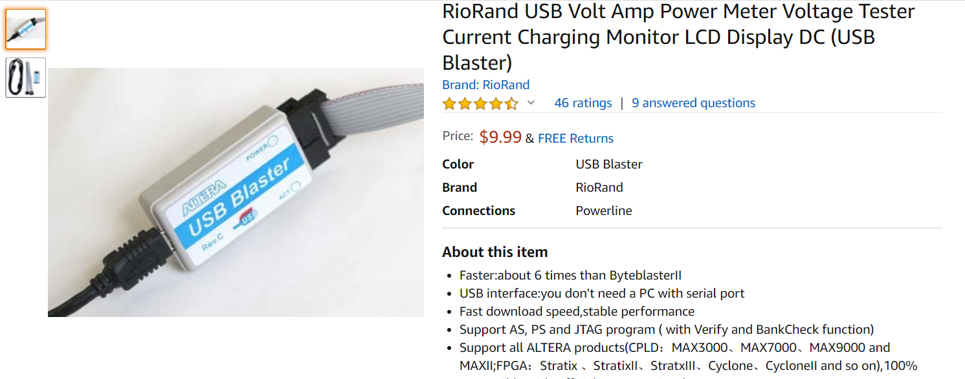

Inside this one, chip is PIC18F14K50. From Win10 Device manager, you can see the USB’s VID=09FB and PID=6001.

Step 2.

Google “Intel FPGA”. Sign up a free individual account on intel.com (FPGA). From the download center.

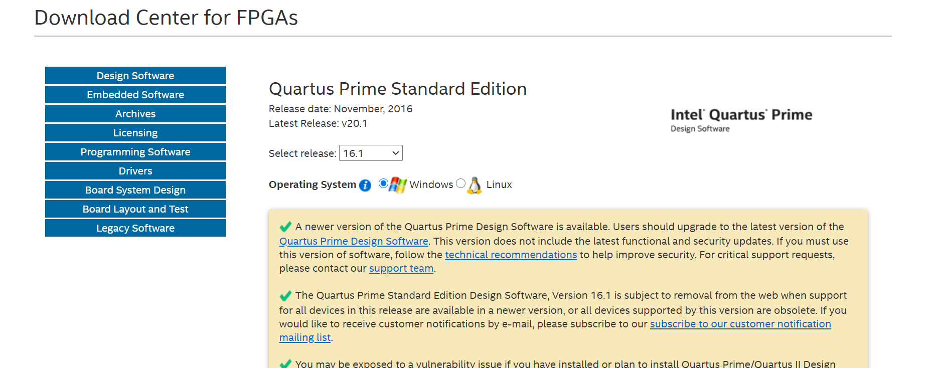

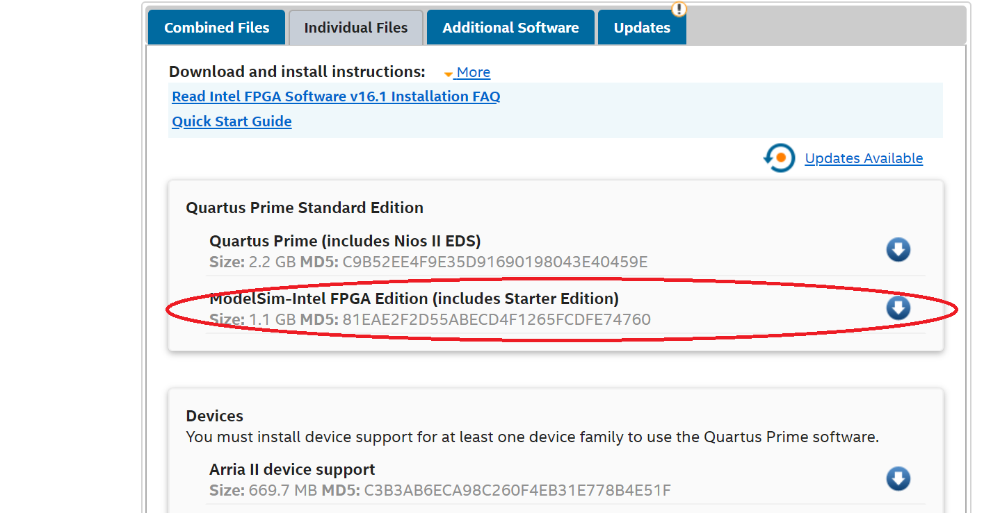

I choose 16.1,( it is stable), and ModelSim since it is smaller (1.1GB). install it on your local PC.

Step 3.

On the same intel download center, go to “Additional Software” tab. See below.

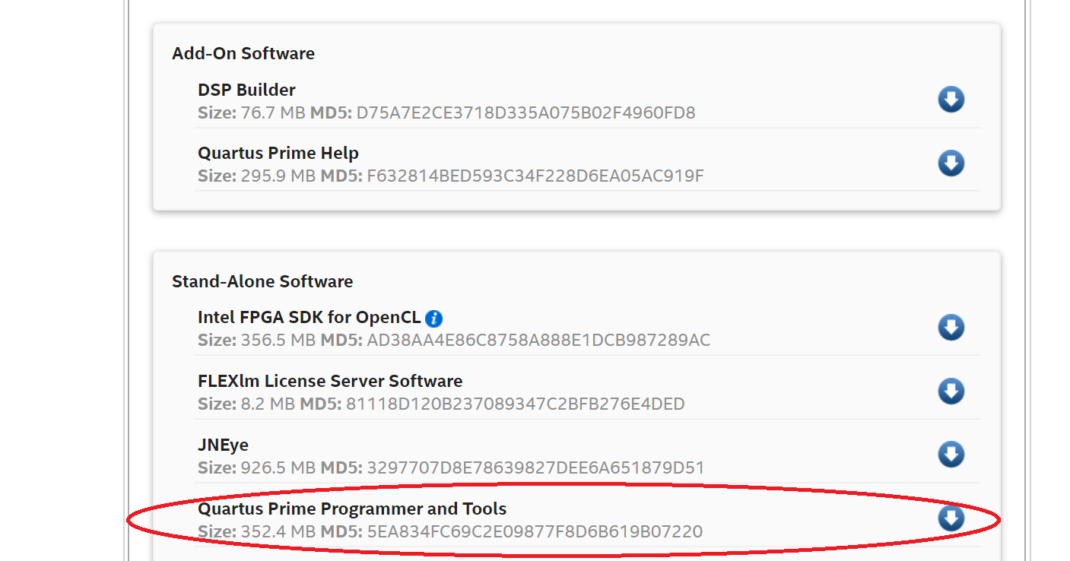

Download the one (red marked) and install it on the same director as ModelSim. Check all the “Launch…” after the main installation. Then you can close all the programmer tools.

Step 4.

Plug in the clone “Altera USB Blaster” to your PC. It will not automatically install the drive since it is a clone. You need to goto Device Manager--🡪 Altera USB Blaster-🡪Properties-🡪Driver-🡪Update Driver-🡪Browse my computer for drive software-🡪select the director as below.

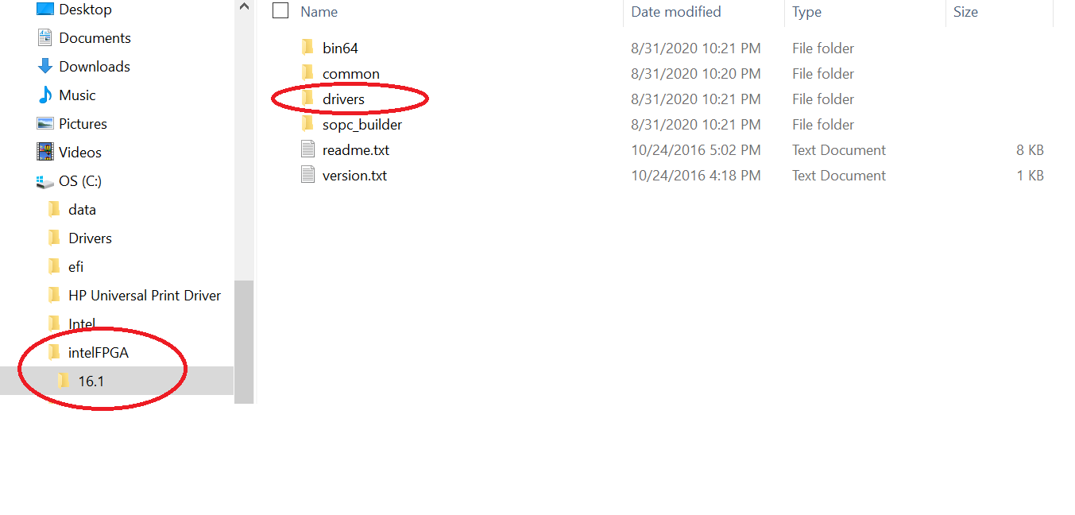

That is it. Hope this can help you.